Xoel – Pós – Alterar meu plano

;change-number 5511944095902

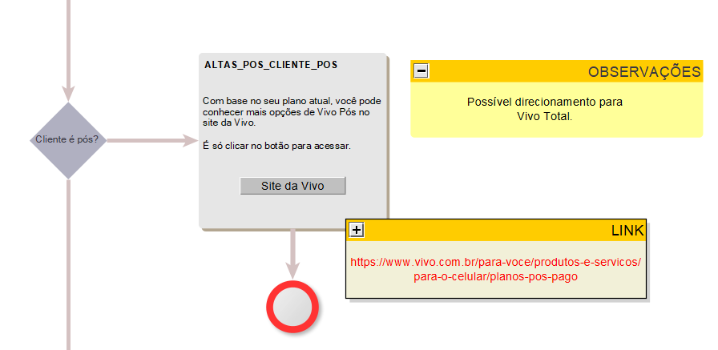

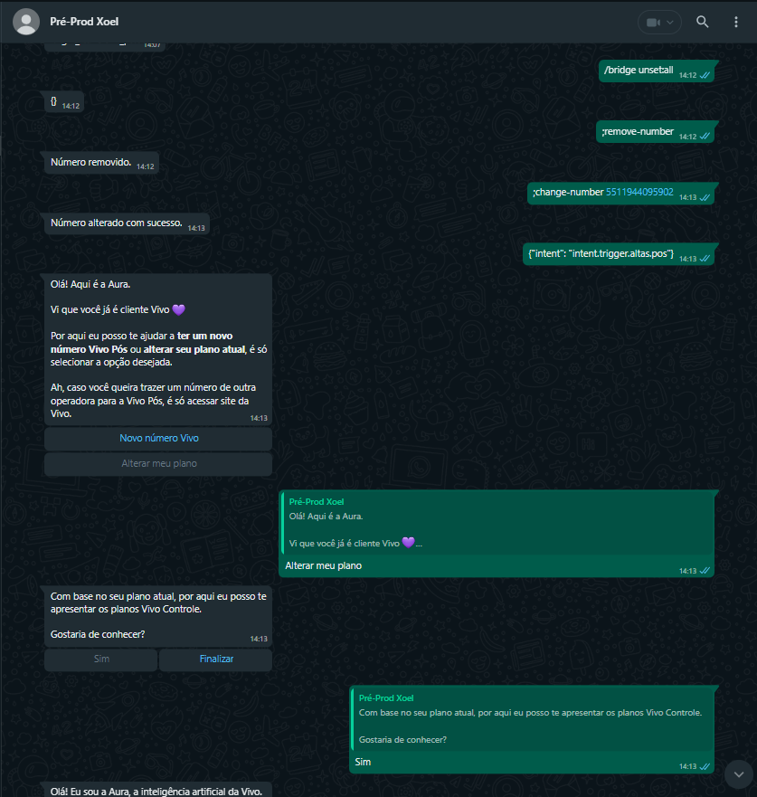

Teste 2 ;change-number 5511944096463

